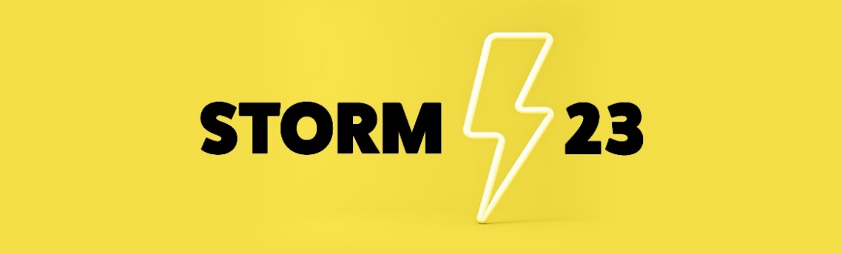

Name:
Address:
Email address:
Mobile No:

Which Art form(s) do you work in (tick as many as apply):

☐Actor
☐Dancer
☐Designer
☐Director
☐Musician
☐Writer

☐Other (please specify):

When did you start your career and what is your favourite job to date?

What do you wish to gain during Storm 23?

Do you have any additional access requirements?

If so, please let us know how we can best support you to ensure you have the best working conditions. Please note the weekend will be BSL Interpreted

If you are a parent/guardian with childcare commitments, please let us know how we can best support you to ensure you can join us fully:

Please email your form to Donna Mullings: d.mullings@derby.ac.uk

