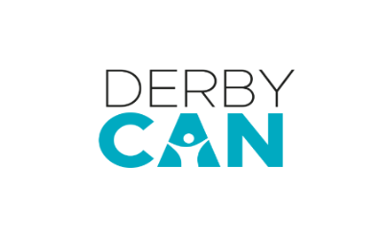
Derby CAN Trained in Derby
Application Form (for ages 18+, no upper age limit)
Co-Creation Show
Name:

Date of Birth:
Address:
(Applicants must live within a 5-mile radius of Derby City Centre)

Email address:

Contact phone number:

Please detail any access requirements:
(Please also let us know if you would like access to fill in this form.)

Please tell us a bit about yourself:

- Have you ever participated in anything like this or performed in any way before?
- What are your interests?
- List any specific skills that you have

Why are you interested in being involved in Over to You?

What to do now

- Email your application form to the Derby CAN team with Over to You Co-Creation Show in the subject line of your email at derbycan@derby.ac.uk
- You can also send an audio or video application, including an application in British Sign Language. Please attach the files in an mp4 format, ensuring that they are no higher than 10MB, and send them to derbycan@derby.ac.uk via a wetransfer link: https://wetransfer.com/
- Check out the Derby Theatre website and search Revel Puck Over To You
- Send us a message on social media @derby_can (Twitter or Instagram) and we can tell you more!
Deadline to apply:
Monday 1 Aug 2022, by 12pm
(We will let you know if we can offer you a place by Friday 5 August)

All levels of experience welcome to apply:
This might be something brand-new you are interested in learning about, or you might be looking for something to put on your CV. We welcome anyone who fits the above criteria. We actively and positively encourage all ethnicities, abilities, and anyone with any access needs to apply.

Dates:
Workshop Dates:
Saturday 13 and Saturday 20 August, plus Saturday 3 September, 10am until 6pm
Rehearsal and Performance Dates:
Monday 5 – Saturday 10 September
(You will need to be available each evening from Mon 5 – Fri 9 Sep, and all day on Sat 10 Sep.)
With the help of a professional theatre maker, we want you to be a part of creating a brand-new show using the ideas generated in the workshops.
Creating and Making Sessions:
Monday 5 – Friday 9 September, during the evening.

