

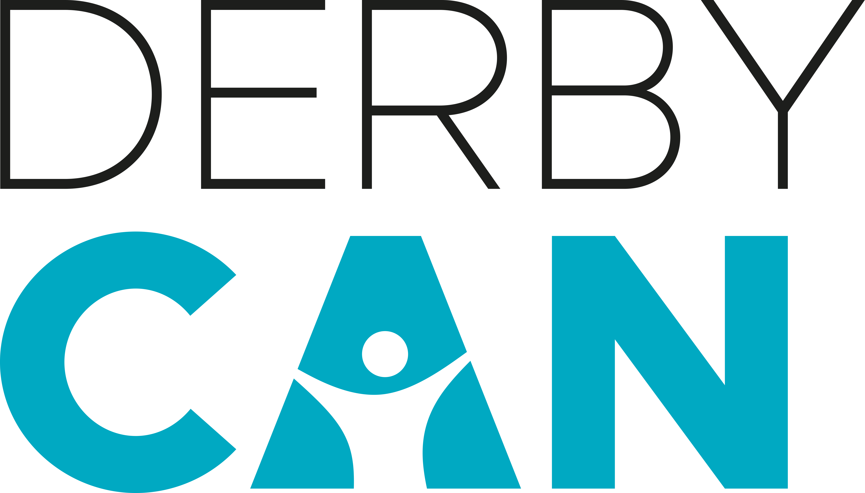

**4 Walls Community Ensemble   
AUDITION APPLICATION**

* **Please complete the details below and send to:** [**derbycan@derby.ac.uk**](mailto:derbycan@derby.ac.uk) **by Tuesday 1 August, 5pm.** (Auditions will be held on Thursday 3 August).
* **Please place ‘4 WALLS AUDITION APPLICATION’ in the subject line of your email.**

**Name** ……………………………………………………………………………….

**Home postcode** ……………………………………………………………………………….

**Phone number** ……………………………………………………………………………….

**Email address**  ……………………………………………………………………………….

**I confirm I am 18 years old or over** ……………………………………………………………………………….  
  
**I confirm I am available for all of the   
production week day time and evening** ……………………………………………………………………………….

**PHOTO REQUEST  
Please send a photo of yourself with this application form**

**Key information**

* Auditions are open to anyone aged 18+ who lives in the Derby/Derbyshire area.
* We welcome interest from all genders, ethnicities and abilities to apply for an audition slot.
* This is a NON-PAID opportunity. However, we may be able to support in contributing towards some expenses.
* Previous experience in performing is not essential, but an eagerness and energy to perform, and a strong commitment to the production, is. If you are a budding performer from the local region, this is a fantastic opportunity to be involved in a professional show on your doorstep.
* Successful auditionees will be offered a place on a 90-minute group audition slot and will take part in a range of group drama/movement/singing exercises. You will need to wear comfortable clothes and footwear and bring along a bottle of water for refreshment.
* Rehearsals will start on Monday 7 August. Community ensemble members will be rehearsing **at least** two afternoons/nights a week (Mon – Fri) with specific days and times to be confirmed. There will also be a rehearsal on Saturday 2 September, 10am until 4pm where **all** company members will **need** to be available to attend.
* Rehearsals will take place at Derby Theatre’s rehearsal studio on Forman Street in Derby.
* For successful auditionees: you **must** also be available **all** days **and** evenings between **Monday 4 and Saturday 9 September.**

**ANY QUESTIONS?**  
**If you have any questions in advance of applying for an audition slot, please email:** [**derbycan@derby.ac.uk**](mailto:derbycan@derby.ac.uk)