**Audio Description and Audio Enhancement**

### Audio Description

Audio Description is a live, verbal commentary providing an explanation of the visual information that Blind or partially sighted people may need to understand and enjoy the show, via a personal headset or hearing aids.

### Audio Enhancement

Audio Enhancement means that the sound on stage is amplified via a personal headset or hearing aids. People with hearing loss may need this to understand and enjoy the show.

**Sennheiser MobileConnect**

MobileConnect is a WiFi-based system. It is available through your personal device, such as your smartphone or tablet, by downloading the Sennheiser Mobile Connect app.

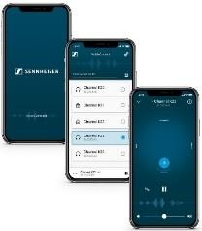

Download the Sennheiser MobileConnect app from the app store on your device. Make sure this is the device you will be bringing with you.

You can find this by searching ‘Sennheiser MobileConnect’ in the Apple or Google Play app store. Or by using the links below:

* [MobileConnect for Apple devices](https://apps.apple.com/gb/app/sennheiser-mobileconnect/id848127271)
* [MobileConnect for Android devices](https://play.google.com/store/apps/details?id=de.sennheiser.sst.mobileconnect&hl=en_GB&gl=US&pli=1)

The icon for the app looks like this:

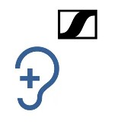

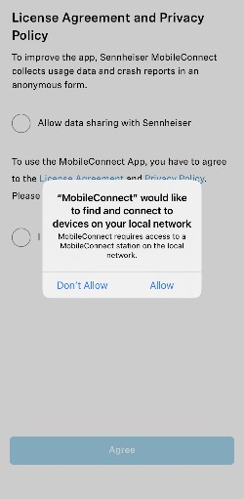When you open the app, an action box may appear asking if the app can connect to devices on your local network.

Please click ‘Allow’ as this will let you connect to the Audio

Description or Audio Enhancement channels. If you click ‘Don’t Allow’, you will not be able to access either service.

You do not need to register or log in to use the app.

Please make sure your device is fully charged before you arrive.

**What to Bring**

Please bring your personal device with the Sennheiser MobileConnect app downloaded on it.

Please bring headphones that are compatible with your device. These can be wired headphones or Bluetooth headphones. Please note, to minimise delays in the audio signal from Bluetooth connections, it is best to use wired headphones.

You can also listen through Bluetooth hearing aids that are Bluetooth v5 compatible (2016 onwards).

## Network

Please turn off mobile data and connect your device to our Wi-Fi. There is no password to the network.

* Name: **OMAM Audio Description**

When you connect to the Wi-Fi, you may get an action box informing you that there is no Internet on this connection. This is correct, please take care to select ‘Connect Anyway’

Once you’re connected to Wi-Fi, open the app on your device.

When you open the app, an action box may appear asking if the app can connect to devices on your local network.

Please click ‘Allow’ as this will let you connect to the Audio

Description or Audio Enhancement channels. If you click

‘Don’t Allow’, you will not be able to access either service.

Once you’ve agreed to the terms and conditions, the app will take you straight to the home page when you open it.

You do not need to register or log in to use the app.

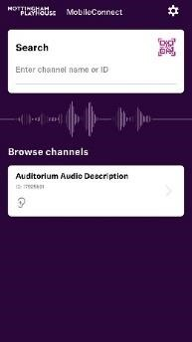The available channels should show up as ‘OMAM AD’.

Click on the channel.

The audio stream will start playing, but you may not hear any sound until the show has started.

Your connection is based on your connection to our Wi-Fi.

Please note that as you move around the building or auditorium, your WiFi connection may change. Once you are in your seat, your Wi-Fi connection should become steady and the channel will stay connected.

MobileConnect is designed to work in Airplane mode, so that phone alerts do not disturb other audience members during the performance. To use this, turn ‘Airplane mode’ on at your phone settings. Ensure that your WiFi connection is still turned on.

## Adjusting the Volume and Tone

When the sound starts, you may need to adjust the volume and tone. To do this, go to the settings icon while on the app.

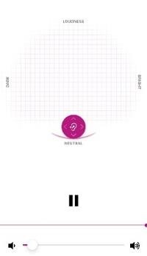

MobileConnect has a simple four-way volume control system. This appears once you have clicked on the appropriate channel. Drag the magenta circle around the screen until the sound is clear.

Dragging the circle higher makes the volume louder and lower quieter. It begins in a ‘neutral’ position.

Dragging the circle right towards ‘bright’ makes the sound crisper. Dragging the circle left towards ‘dark’ makes the sound duller.

There is also a volume slider at the bottom of the screen.

We encourage you to use the first few minutes of the show getting the sound adjusted to the correct level for you.

You are welcome to adjust the volume any time in the performance. You may want to adjust the brightness of your screen so as not to disturb other audience members.